The Pastor’s Page

Wandah and I recently updated our wills. No, we’re not expecting them to be implemented any time soon! Our last ones were done years ago, well before retirement, and several realities have changed for us since then. We also desired to alleviate as much stress as we could on those who will have the responsibility of someday disposing of our assets.

One thing this process has done is to force us to think of what is really most important in our lives. We’ve learned (or re-learned) that much of what concerns us in our day to day lives is, in the final analysis, simply “wood, hay, and stubble.” As the trite old saying goes, “you can’t take it with you.” The stuff that occupies much of our lives will either go to someone else, or will be thrown away. That does not render them as having no value at all, but rather that their value is temporal. We enjoy our “stuff”, and there is nothing wrong with that. But in the end, it’s just “stuff.”

The process has also accentuated how important family is to us. To make sure that our family members benefit from our lives materially after we are gone is an act of love. To involve them in the process has been a good experience.

By far, however, the most important lesson we have been reminded of is how blessed we are to be assured that whenever God calls us home, we will indeed enter our eternal home, the one He is preparing for us. Because of Jesus’ death and resurrection, and the grace that He offers to us, we need have no doubt whatsoever of our eternal destiny. That’s been settled. As the recent hymn “In Christ Alone” (composed by Keith Getty and Stuart Townend) states so well:

No guilt in life, no fear in death, this is the power of Christ in me.
From life's first cry to final breath, Jesus commands my destiny.
No power of Hell, no scheme of man, can ever pluck me from His hand.
'Til He returns or calls me home, here, in the power of Christ, I'll stand.

Because of Him,

Pastor Dave

Peaceful thankful heart

Dear Church Family,
Thank you to ALL of you who sent me a card or prayed for me. I am finally recovering without a 10 on the pain scale and am hobbling around, but I will get there. Sending my Love to You.
Cheryl Morse

AND

Thank you from Burt and Pat Howe for all the cards, prayers and well wishes; they certainly lifted their spirits when they were down.

AND

TO MY CHURCH FAMILY:
I want to thank you from the bottom of my heart for all the prayers for Gary, and the cards and notes for him. It meant alot!
Your continued prayers for me will give me strength and comfort. All the cards I have received with your beautiful notes, I read over.
Again, thank you!
God’s Blessings - Linda Duranceau


Craft items needed:
If you have craft items, that you no longer need, I could put
them to very good use decorating the church. Right now I am
in need of wired ribbon (any color or season), wreaths
(decorated or plain) floral foam and artificial flowers (any
color).
Thank you from your church decorator.
Peggy Grant

FALL BIBLE STUDY
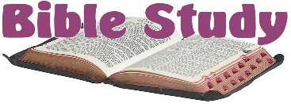
Sadly, my situation has changed, and I am no longer available to lead a fall bible study. I have put out feelers and asked for someone to run the program, but there was no interest. On that note, I am able to start Max Lucado’s book ”3:16 The Numbers of Hope”, on or about February 23rd, 2027. I will order the books, and I expect the cost to be about $5. I feel bad as I like bible study so unless someone is interested in running it with help from me, I look forward to meeting in the spring.
In His name, Andea Dresser

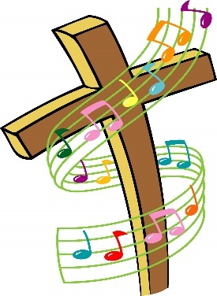
A MEMORABLE DAY!
On August 2nd, we welcomed Mark Thallander to our church as our guest organist. Mark was, for 18 years, the organist at the Crystal Cathedral and the Hour of Power television broadcast. Following an accident in 2003, the Mark Thallander Foundation was established, which brings together people from many churches for musical, instrumental, and choral festivals throughout the US and internationally. He has published several choral hymn arrangements, and co-written the book “Champions Plus”, which details his accident and aftermath with chapters from several people involved in the story (including our own Pastor Dave). His book is available in our church Library.
That same evening at St. Joseph’s Church in Biddeford, the Mark Thallander Foundation presented an evening of faith and music, featuring area choir members, musicians, and of course Mark Thallander at the organ. It was a magnificent presentation of beautiful and familiar tunes, with accents of trumpet, flute, saxophone, piano, soloists and a children’s choir. Combine that with the amazing acoustics of St. Joseph’s, and we had a program that rivaled the Mormon Tabernacle Choir! We are grateful to Pastor Dave for introducing his friend Mark to us, and we hope to have him return to our organ in the future!

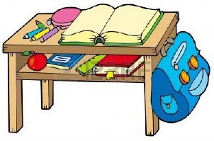
WORKING WITH THE YOUNGER SET
Would you like to work with Linda Blades and Nancy deMiranda, and explore resources to create a Children’s Church? We need multiple “leaders” to facilitate a time during the worship hour, where children would go to do a lesson or have playtime. If you’re ready to step up and be with any child or children who come to church, please email Andrea Dresser at celticmist50@gmail.com and we will set up a time to brainstorm together with Nancy and Linda. This is a very rewarding endeavor – close your eyes and open your heart and let God speak to you!


LIVE STREAM OUR WORSHIP SERVICE
If you are unable to attend a worship service at UBC, or would like to see the service again, you can watch the service live at home. Go to our website: unitedbaptistsaco.org , at the top, click on “sermons”. Then under the blue circle with the letter “U” in it, click “Live”. Next, click on the photo with the date you want to watch.

FALL WORSHIP HOUR
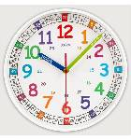
We will be moving our worship service to the 10 o’clock hour starting on September 13th.

See below (or next page) for details of the picnic that will also take place that day.

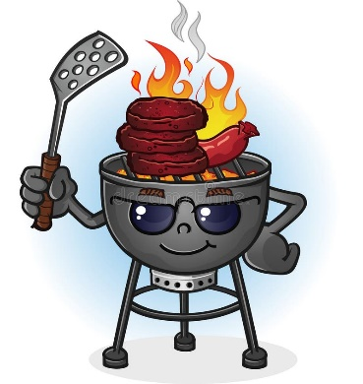
CHURCH PICNIC
Come one, come all to our annual All Church Picnic on Sunday, September 13th, following worship. Our picnic will take place in the Vestry, with the grilling happening in the front parking lot. We will offer hamburgers, hot dogs, corn on the cob, salads, lemonade and home-made desserts. See you there!

THE BUCKET CHALLENGE

The Bucket Challenge for the summer months has been a great success, and we will continue to collect these articles through October. THANK YOU for all your donations of brushes, combs, shampoo and conditioner. The people of United Baptist Church are a very giving people!
Mary Lee Taylor, Ann Nelson, Helen Desjardins, Angie Hutchinson,
David & Irene Hodges


UPDATE FROM THE SEARCH COMMITTEE
All our preliminary work is completed, and we await news of possible candidates. Meanwhile, we did a mock interview with Rev. Steven Guilmain from Kennebunk Baptist Church. It was helpful to the committee; we learned interesting new information. We thank Rev. Steve for giving us his time and his experience.
Cathy Larkin, Search Committee Chair.

HOLLY BERRY FAIR – DECEMBER 5, 2026 – 8:30 – 1:00 PM

It’s coming quickly! We need at least six more volunteers –2 for selling the Christmas wreaths, and 2 to work the center craft table, and a cashier and another helper or 2 on the food table. Speak with either Anne Daisey 207-229-9306 or Sue Bedell 207-283-3757, or Margie 207-590-9666. Questions and suggestions are welcome!
Did you enjoy working on projects during the summer?
Ann Daisey- Chairman
Peggy Grant
Pam Salvas
Sue Bedell

One Great Hour of Sharing Offering


The One Great Hour of Sharing Offering (OGHS) began seventy-seven years ago in response to the devastation of World War II. On Saturday evening, March 26, 1949, a national broadcast titled “One Great Hour” featured a remarkable assembly of national leaders and celebrities. President Harry Truman addressed the nation and urged people to give, to help the suffering in foreign lands. The broadcast concluded asking Americans to give generously the next morning in their churches. More than 75,000 churches responded.

Today OGHS serves people in eighty countries around the world, and is a joint effort by five denominations, and in partnership with Church World Service. Funds are used for two purposes: to provide relief to areas hard hit by natural and man-made disasters; and to assist development projects in needy areas. OGHS distributes resources in cooperation with our ministry partners on the ground, ensuring that contributions get to those who need them. 100% of contributions go to help needy people – no administration costs are deducted from this offering.

Throughout the summer months, United Baptist Church gave $1142 gave to this very worthy endeavor. It is truly our love offering in the Name of Christ to the world. Congratulate yourselves! You may give at any time, making sure you indicate that your gift is to go to OGHS.

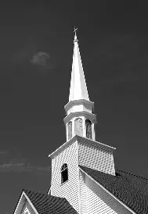
WHAT’S GOING ON AROUND HERE?? The trustees have authorized much needed work to be done on our steeple, cupola and side porch next to the credit union, and part of the roof on the Sunday School wing. The cupola has a fresh coat of white paint, and the broken lattice work on the steeple has been updated and replaced. New shingles and a repaired weather vane are forthcoming. Take a walk out front and look up! Our Main St. doors got their final coat of paint. Lookin’ good, aren’t we? Thank you, trustees, for taking good care of this “Grand Old Lady”!


BACKPACK PROJECT!
Well, the kids are just about back to school, and a BIG THANK YOU goes out to all who donated backpacks and school supplies. Sue Bedell and friends have distributed your generous gifts to Saco schools. It’s a good feeling to know we can help those who need a little assistance!

THE MARK THALLANDER FOUNDATION
Will be presenting 2 two musical programs:
First, The New England Festival of Organ Music, featuring Hector Olivera
Sunday, September 20th at 3 pm, at the Basilica of Saints Peter & Paul
122 Ash St, Lewiston, ME 04240 (207) 777-1200
And
The New England Fall Organ Festival, featuring Bradley Hunter Welch
Sunday, October 18, at 6pm.
First Parish Church, 218 Central Ave, Dover, NH 03820 (603) 742-5664
Go to markthallanderfoundation.org for more information.

Here is a “primer” on outlets and power strips.
Things that create heat – printer, portable heater, coffee urn- and
Things that create cold – refrigerator, freezer, AC unit - take a lot of electricity.
The 6-way outlet adapters and inexpensive power strips are made with less brass/copper and don’t do well handling the amount of electricity required to heat and chill. That’s why they’re inexpensive. It is suggested to purchase $60 or more power strip. They are made with more brass/copper so they can handle the electrical flow properly. That’s why they are more expensive.
It is suggested to get an “AC extension cord” to use for a coffee urn. They come in 3 foot lengths and are made to handle a heavier flow of electricity.
Like most everything else, outlets wear out. There are tension springs that hold the prongs of an electrical plug in the outlet. If what you’re plugging in slides in and out easily, the outlet should be replaced.
If the plug itself is warm or hot when you grasp it to remove it from the outlet, cup your hand over the outlet and see if it’s warm. Yes? It’s worn out and transferring heat. Think…..ELECTRICAL FIRE IN THE WALL IS NOW A REAL POSSIBILITY. I have probably bored some of you, but I hope to have passed along some useful information. Thank you 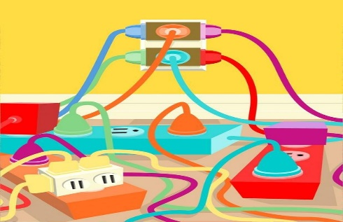

* * * * * * *

United Baptist Church
318 Main St.
Saco, ME 04072

September 2026
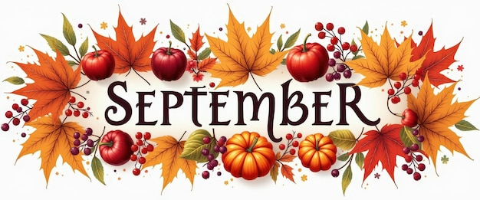
UNITED BAPTIST CHURCH STAFF
INTERIM PASTOR: Rev. Dr. David Clark SECRETARY: Margie McDonald
BOOKKEEPER: Danielle Roberge MUSIC COORDINATOR: Glenn Moseley
ORGANIST: Janice St. Cyr
CHURCH OFFICE HOURS - TUESDAY – FRIDAY 8:00am – Noon
Church Office: (207)283-3411 Pastor Dave (207)513-0114
Emails: rev.drc1952@gmail.com ubcsaco.office@gmail.com
Web site: unitedbaptistsaco.org - friend us on Facebook: sacounitedbaptistchurch

