The Pastor’s Page

It is now spring, though as I write this, it doesn’t look much like Spring. I look out my window and see a snow-covered yard. However, soon the snow will be gone, the crocuses and daffodils will begin poking their heads through the previously frozen ground. Lightweight jackets will replace heavy coats. We’ll put the snow shovels away in favor of rakes. Baseball will replace ice hockey. Who doesn’t love Spring!

In 1970, Kurt Kaiser wrote a song which is seldom heard anymore. It is entitled “Bring Back the Springtime.” The chorus goes like this:
Lord, to my heart bring back the springtime.
Take away the cold and dark of sin.
Oh refill me now, sweet Holy Spirit:
May I warm and tender be again.

It is easy to fall into times when God seems distant, when serving Jesus becomes more of a duty than a privilege, when worship becomes more ritual than reality. Our relationship with God seems to be stuck in neutral. In a sense, we experience a “spiritual winter.” Maybe you know that feeling. Maybe some of us are experiencing that now. If so, we need to ask God to renew and revive us. He has promised to do that when we call upon Him.

I think King David must have had Spring in mind when he stated in Psalm 23: “He makes me to lie down in green pastures. He leads me beside still waters, He restores my soul.” What a wonderful image upon which to meditate. I suggest you do exactly that, not just during Spring, but through all seasons of your life.

For His Kingdom,
Pastor Dave
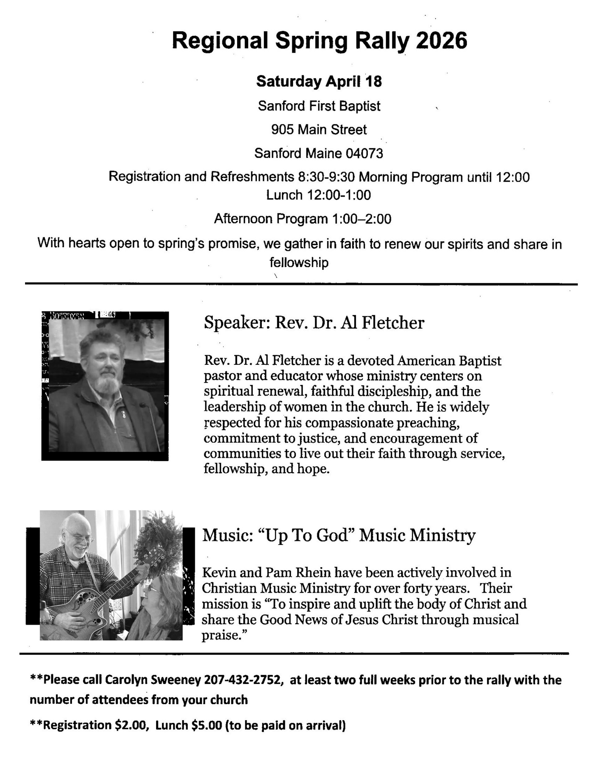
HOLY WEEK
Palm Sunday, March 29 with worship at 10:00am. A festival day with special music and palm leaves for all as we remember Jesus entering Jerusalem.
Maundy Thursday, April 2 with worship at 7:00pm. This is a solemn service of communion, scripture, and light as we remember the events surrounding the Last Supper and the Garden of Gethsemane.
Good Friday, April 3, The Sanctuary will be open from 8:00-Noon for prayer and remembering the events surrounding the crucifixion of Jesus.
Sunrise Service, April 5, at 6:00 on the beach at Temple Avenue. You are encouraged to join the traditional sunrise service on the beach at the end of Temple Avenue. The Salvation Army Band will play during the service as we watch the sun rise over the ocean on Easter morning, declaring “He Is Risen!”
Easter, April 5, with worship at 10:00am. What can be more glorious than a service celebrating the resurrection of our Savior, Jesus Christ! Our service will be filled with majestic music, fantastic floral displays and the powerful scripture and message of the gift of New Life.
Let’s fill the sanctuary by inviting family and friends,
and join together in celebration!

MAUNDY THURSDAY SERVICE
What is "Maundy Thursday?" The title comes from the Latin for "command", remembering Jesus' giving to His followers a "new commandment" to love one another. The events of Thursday - Jesus washing His disciples' feet. The Last Supper, Judas' betrayal, Jesus' agony in the Garden of Gethsemane, His arrest and the abandonment by His disciples - all of these happened in just a few hours. At our Maundy Thursday Service, (April 2, 7:00pm) we will remember them by celebrating Communion, and experiencing Tenebrae, in which the Scriptures are read and the lights gradually extinguished. It is solemn service, and is meant so we can experience in some way the gloom of that day. Many have said that they find it the most spiritually meaningful service of the year. All are welcome.

Easter Sunday: April 5th
"Christ is risen! He is risen indeed". That is the proclamation of Easter Sunday. We sing our alleluias and rejoice in the victory of Jesus' resurrection. The day will begin with a Sunrise Service at 6:00am at the foot of Temple Avenue in Ocean Park. We will then gather at the church at 10:00am for our Resurrection Day Worship Service. Join with others as we celebrate together the greatest victory the world has ever experienced, and the basis of our hope as believers.

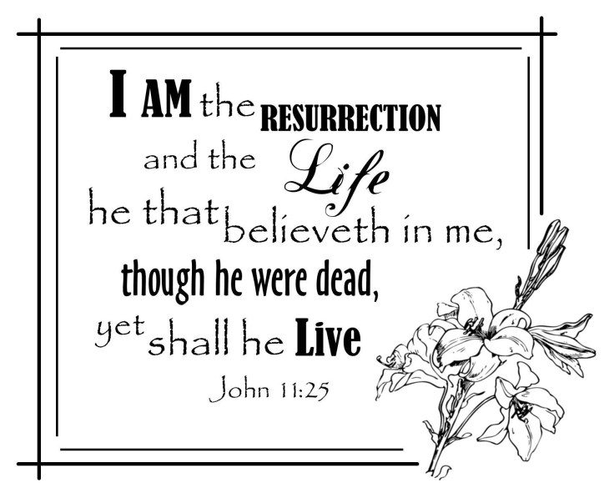

AMERICA FOR CHRIST OFFERING
Throughout March, we have collected monies for the “America for Christ” Offering. So far, we have collected $913.00. The monies donated are divided up between our own region (Maine) and the American Baptist Home Mission Society. Monies are used to help fund a wide array of ministries in the USA and Puerto Rico. The need is great! You may use the envelopes in the pews for your contribution.

SPRING BREAK FUN!
The Board of Christian Education would like to announce a project for our Sunday School Students! On April 21, 2026, we will meet in the Vestry to assemble a Decorative Nightlight. Upon completion of the project, there will be a pizza luncheon. This is open to all Sunday School students.
For more information you can contact Bill or Mary Jones at 207-294-1609.

STUDENTS NEED TEACHERS!
The Board of Christian Education is looking to expand the Sunday School teaching staff.
We’d like to start a class for 8-11 year olds. The curriculum would be provided. If 4 people to step up, that would allow for a one Sunday per month rotation.
If you are willing or would like more information, please speak to Andrea Dresser,
call 207-347-0500 or email celticmist50@gmail.com. This is a very rewarding job, and we hope God is speaking to you now as you read this piece.

BELL CHOIR
Marie Burgie (207-590-4944) and several others are starting up the bell choir. We would love to have a larger group. No experience is required, just come and bring your enthusiasm! Together we will all learn! We will meet Wednesdays in the sanctuary at 5-6 pm. Come on and ring those bells!!

MISSION NEWS
The Bucket Challenge for March has been a great success. THANK YOU for all your donations of much needed dental products and hand warmers. The people of United Baptist Church are very giving people!
For the month of April we will be collecting men's & lady’s underwear. Seeds of Hope in Biddeford is requesting the following items:
New Men’s briefs in Small, Medium & Extra Large ONLY.
New Women’s underwear in sizes 5 & 8 ONLY.
Please stay tuned for different items we will be collecting each month. Your generosity fills a very important need in our community!
Your Board of Mission,
Mary Lee Taylor, Ann Nelson, Helen Desjardins, David, Hodges, Irene Hodges & Angie Hutchinson.

AN EXCERPT FROM THE KALKMAN’S NEWSLETTER
“This war has changed us forever. We have learned to trust more in the Lord, not politicians, and to cherish one another. We know all too well the true value of simple things: light in our homes, warmth in the radiators, silence without explosions.

We dream of peace. We pray for peace. We work for peace." Nadia, Kharkiv, Ukraine
You may read the entire letter which can be found on the small white table in the vestry.

FOOD COMMODITY DISTRIBUTION
On the first Thursday of every month, we partner with Wayside Food and Good Shepherd to offer 40-pound boxes of food along with fresh produce to senior citizens. Individuals fill out paperwork and return it to Wayside Food to get on the distribution list. On the first Thursday of the month between 8:30 and 12:30, they drive to our church back parking lot where volunteers check them off the list and put a box in their car.
UBC has been offering this program since June of 2017 distributing around 129 boxes each month. It is a well-run program that really helps a lot of people!
We are in need of more volunteers to keep this program going. If you can offer an hour or two between 8:30 and 12:30 on the first Thursday of the month, please let Bill Soucy or Carolyn Gawron know you’d like to help and we will add you to the list of volunteers!


UBC RECYCLES
Yes!! We now have a new container for you to drop your plastic water bottles into. It will have the green “CLYNK” bag inside to accept bottles with the 5 Cent deposit. That includes grape juice bottles, soft drink and Hawaiian punch bottles.
ALSO we have the traditional blue wastebaskets with the recycling triangle located at each door of the sanctuary, and one beside the 3-bay sink in the kitchen. Please use these for recycling the bulletins, cardboard tubes, juice cartons and the like.


THINGS TO KNOW and HOW TO DO...
There is a red notebook in the wall pocket outside the secretary's office door. In it, you will find all the items that now need to be taken care of and how to do them, now that Beverly has retired. Take a look and see what TASKS you could help out with. The notebook will remain outside the office for all to reference in the event the office is closed. If you would like photocopies of particular pages, see Margie

CELEBRATING A BIRTHDAY?
Cheryl Morse, Chair of the Sunshine Committee, would love to send you a birthday card. There’s no need to give out the year you were born; just the month and day. Speak to her at church, email her at JMorse5@maine.rr.com, text/call 207-590-1233

MEMBERSHIP
If you are interested in joining our church, the pastor would be delighted to talk with you about this important decision. We welcome new members upon their confession of faith in Jesus Christ, by baptism, letter of transfer from another church, or by Christian Experience. Associate membership is also available for those wanting to maintain membership in another church while living year-round or seasonally in our community.

MEMBERSHIP STEPS
Step 1. Notify the Pastor of your interest in or decision to seek membership
Step 2. The Pastor will want to meet with you to become better acquainted and share information about the church and respond to any questions.
Step 3. You will be invited to attend an informal orientation session. The Pastor next recommends your request for membership to the Diaconate for consideration and celebration.
Step 4. The Right Hand of Fellowship is extended during a Sunday service as a gesture of welcome, and as a time of covenant.

God teaches us through stories that all of His creation has value.
“The earth laughs in flowers.” - Ralph Waldo Emerson
“April hath put a spirit of youth in everything.” - William Shakespeare
“Why do you worry about clothes? See how the flowers of the field grow. They do not labor or spin. Yet, I tell you that not even Solomon in all his splendor was dressed like one of these.”
Matthew 6:28-29 NIV

What does the Bible say about Spring? This season is a time of warming weather and nature coming back to life. As flowers bloom and animals are born, we are reminded of the innocence and beauty that exists in this world, and that there is new life all around us. As Christians, we are given new life and new mercies every morning. Spring provides a wonderful reminder to us that we should be living a full life and leaving the old dead parts of life behind. There is always hope during the coldest, darkest winters of life. Spring will come and new life will come forth!
“Let My teaching fall like rain and My words descend like dew, like showers on new grass, like abundant rain on tender plants.” Deuteronomy 32:2
Just a few Giggles
Just like God
My grandson was visiting one day when he asked, "Grandma, do you know how you and God are alike?"
I mentally polished my halo while I asked, "No, how are we alike?"
"You're both old," he replied.

The accountant
An accountant dies and goes to Heaven. He is met by St Peter who goes through the usual questionnaire.
"What sort of accountant are you?" says St Peter
"Public Practitioner," is the reply.
"Name?"
He gives his name. St Peter goes through some files and pulls one out.
"Oh, yes. We've been expecting you. You've reached your allotted span," says St Peter.
"How can that be?" says the accountant. "I'm too young to go. I'm only forty-eight"
"No, that's impossible."
"Why do you say that?"
"Well we've been looking at your time sheets and the hours you've charged your clients. By our reckoning you're at least ninety three."

Hot sauce
A minister who was very fond of pure, hot horseradish always kept a bottle of it on his dining room table. He offered some to a guest, who took a big spoonful.
When the guest finally was able to speak, he gasped, "I've heard many ministers preach hellfire, but you are the first one I've met who passed out a sample of it."

* Don't let worry kill you--let the church help.

* Remember in prayer the many who are sick of our church and community.

* For those of you who have children and don't know it, we have a nursery downstairs.

* Weight Watchers will meet a 7 p.m. at the First Presbyterian Church. Please use large double door at the side entrance.

* Jean will be leading a weight-management series Wednesday nights. She's used
the program herself and has been growing like crazy!

* The rosebud on the altar this morning is to announce the birth of David Alan Belzer, the sin of Rev. and Mrs. Julius Belzer.

* This afternoon there will be a meeting in the South and North ends of the church. Children will be baptized at both ends.

* Tuesday at 4:00 p.m. there will be an ice cream social. All ladies giving milk will please come early.

* This being Easter Sunday, we will ask Mrs. Lewis to come forward and lay an egg on the altar.

UNITED BAPTIST CHURCH
318 MAIN STREET
SACO, MAINE 04072

APRIL 2026


UNITED BAPTIST CHURCH STAFF
INTERIM PASTOR: Rev. Dr. David Clark SECRETARY: Margie McDonald
BOOKKEEPER: Danielle Roberge MUSIC COORDINATOR: Glenn Moseley
ORGANIST: Janice St. Cyr
CHURCH OFFICE HOURS - TUESDAY – FRIDAY 8:00am – Noon
Church Office: (207)283-3411 Pastor Dave (207)513-0114
Emails: rev.drc1952@gmail.com ubcsaco.office@gmail.com
Web site: unitedbaptistsaco.org - friend us on Facebook: sacounitedbaptistchurch

