CELEBRATION OF WORSHIP
June 7, 2026 - 10:00 a.m.
"If you believe what you like in the Gospel, and reject what you don't like, it is not the Gospel you believe, but yourself." St. Augustine
Welcome and Announcements
Centering Prayer
“Lord, speak, for Your servant is listening.” 1 Samuel 3:10

Organ Prelude: “St. Columbia and Garden” JD Wilson Janice St. Cyr, Organist
Call to Worship: Psalm 135
Leader: Praise the Lord! Praise the Name of the Lord; give praise, O servants of the Lord,
People: Praise the Lord, for the Lord is good; sing to His name, for He is gracious.
Leader: For I know that the Lord is great; our Lord is above all gods.
People: Your name, O Lord, endures forever, Your renown, O Lord, throughout all ages.
Invocation
* Gathering Song: # 1 “Joyful, Joyful, We Adore Thee”
Communion Service
Words of Invitation
Words of Institution
- The Bread
- The Cup
Prayer of Commitment
Hymn: # 513 “O, How He Loves You and Me” (seated)
Gathering of Our Offerings
Offering envelopes are available in the pews.
Jesus said, “Freely you have received, freely give.” (Matthew 10:8)
*Hymn: # 368 “All for Jesus” (verses 1 & 4)
*Prayer of Dedication
Offertory: “You Are Mine” D. Haas
Pastoral Prayer and The Lord’s Prayer
Prayer Response: #383 “Open Our Eyes, Lord” (seated)
Scripture: Jonah 3:1-10 Read by Robert Talley
The word of the Lord came to Jonah a second time, saying, ²“Get up, go to Nineveh, that great city, and proclaim to it the message that I tell you.” ³So Jonah set out and went to Nineveh, according to the word of the Lord. Now Nineveh was an exceedingly large city, a three days’ walk across. ⁴Jonah began to go into the city, going a day’s walk. And he cried out, “Forty days more, and Nineveh shall be overthrown!” ⁵And the people of Nineveh believed God; they proclaimed a fast, and everyone, great and small, put on sackcloth.
⁶ When the news reached the king of Nineveh, he rose from his throne, removed his robe, covered himself with sackcloth, and sat in ashes. ⁷Then he had a proclamation made in Nineveh: “By the decree of the king and his nobles: No human or animal, no herd or flock, shall taste anything. They shall not feed, nor shall they drink water. ⁸Humans and animals shall be covered with sackcloth, and they shall cry mightily to God. All shall turn from their evil ways and from the violence that is in their hands. ⁹Who knows? God may relent and change his mind; he may turn from his fierce anger, so that we do not perish.”
¹⁰When God saw what they did, how they turned from their evil ways, God changed his mind about the calamity that he had said he would bring upon them, and he did not do it.

Message: “A Second Opportunity” Pastor Dave
*Closing Hymn: #371 “Have Thine Own Way, Lord”
*Benediction
Postlude: “He’s Everything to Me” R. Carmichael

* Denotes please stand, as you are able

Please join us downstairs in the Vestry for a time of fellowship

WELCOME! We of United Baptist Church represent various religious and cultural backgrounds and lifestyles. We are young, old, and middle aged, single, married, widowed, divorced, parents, grandparents, and members of extended families. Above all, we are people who take risks, make mistakes, confess, repent and try again. At the center of our community is Jesus Christ whose life, death, and resurrection are the reasons we are together. The life and hope in this community have more to do with Christ’s faithfulness to us than ours to Christ. Whether you are searching for a faith community, or just passing through, we want you to feel at home. Whoever you are, whatever your history, your scars, your gifts, you are among people like yourself.
FLOWERS:
Are in loving memory of Brian St. Cyr from his parents, Janice and Steve
Are in celebration of ML Taylor’s birthday
Are in honor of Marianne & Howard Krueger, celebrating their 70th anniversary
GREETERS: Keith Welch Barb Jones
FELLOWSHIP HOUR: the Board of Deacons
SERVING COMMUNION: Bob Maxfield, Mary Maxfield, Carolyn Gawron,
Bill Soucy ASSISTING PASTOR DAVE: Ken Maxfield
SPECIAL CARE CORNER
Gary Duranceau  Howard & Marianne Krueger  Peggy Ricker  Bill Tarbox  Burt Howe | Cliff Kenney  Linda Fondak  Cindy Neal  Clara Pate  Mary Jones

UNITED BAPTIST CHURCH STAFF
INTERIM PASTOR: Rev. Dr. David Clark SECRETARY: Margie McDonald
BOOKKEEPER: Danielle Roberge MUSIC COORDINATOR: Glenn Moseley
ORGANIST: Janice St. Cyr
CHURCH OFFICE HOURS: TUESDAY – FRIDAY 8:00am – Noon
Church Office: (207) 283-3411 Pastor Dave: (207) 513-0114
Emails: ubcsaco.office@gmail.com rev.drc1952@gmail.com
Web site: unitedbaptistsaco.org – Friend us on Facebook: SacoUnitedBaptistChurch
The Past Has a Future at United Baptist!

THE UNITED BAPTIST CHURCH
318 Main Street. Saco, Maine 04072

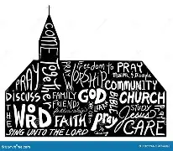

The Church in the Heart of Saco

OPPORTUNITIES AND INFORMATION
THE WEEK AHEAD:
TUESDAY Voting Day !
WEDNESDAY 9:30 am – Little Folk Graduation (private)
5:00 pm – TOPS
6:00 pm – Bills Committee
6:30 pm – Boards and Committees' meetings
7:30 pm – Church Council meeting
NEXT SUNDAY: Be sure to come! We will be recognizing those in our church family that are graduating, and recognizing our Sunday School students.

IMPORTANT ANNOUNCEMENT-EFFECTIVE IMMEDIATELY
Do to the troubling conditions in our society today, it has been decided to lock the Main Street doors when the church service starts. This will be the responsibility of the Main St. door greeters. The back parking lot doors and the Credit Union side porch doors will remain unlocked.

TIME CHANGE
June 28th we will begin our worship service at 9 am.

MISSION UPDATE-JUNE BUCKET CHALLENGE!
The Bucket Challenge for May has been a great success! THANK YOU for all your donations of disposable rain ponchos and gas cards.
For the month of June, we are requesting donations of brand new and unopened hairbrushes and combs, shampoo, and conditioner (sample size OK).
Your continued giving fills a very important need in our community and is a blessing to those less fortunate. THANK YOU again for your generosity!!

PASTORAL CARE
Contact Pastor Dave directly: rev.drc1952@gmail.com or 207-513-0114

PERFUMES AND COLOGNES
Please be aware, some in our congregation are sensitive to, and/or have allergies to fragrances. Please limit your use of these when attending church gatherings.

OPPORTUNITIES AND INFORMATION

LIVE STREAM OUR WORSHIP SERVICE
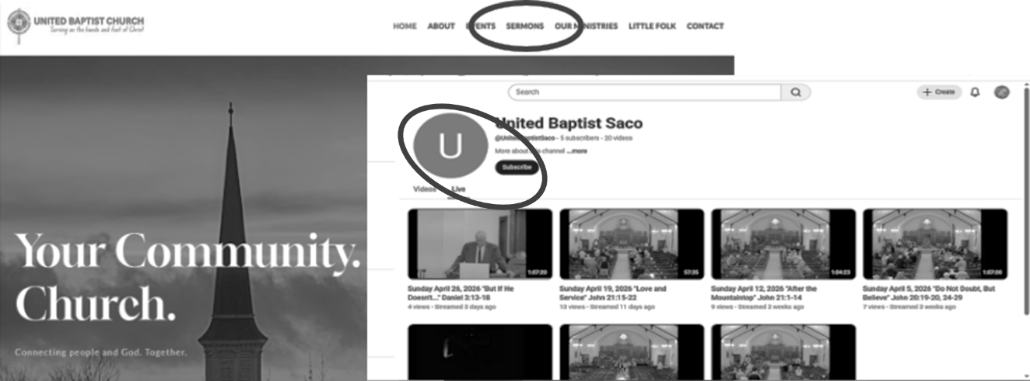

Go to our website: UnitedBaptistSaco.org , at the top, click on “sermons”. Then under the blue circle with the letter “U” in it, click “Live”. Next, click on the photo with the date you want to watch.

OFFERING ENVELOPES
Do you have yours? If not, there are some in the back of the sanctuary. Choose an envelope number and sign your name to that number on the sheet. Using your envelopes is how we keep track of your giving. In January, for tax purposes, you are issued a statement for non-profit giving.

DECEMBER IS JUST SIX MONTHS AWAY!
That’s right - our Holly Berry Fair is the first Saturday of December, the 5th. NOW is the time to get into the holiday spirit by joining in and donating your time and working on your knitted and crocheted items, crafts jams, jellies, pickles and relishes. Got some good, working Christmas decorations that are unused? Donate them to Grandma’s Christmas Attic. How about that jewelry you never wear? Cheryl will take it and turn it into profit for our church! Want more information?
Ann Daisey is the Chairperson for 2026! 207-229-9306 daiseym266@gmail.com

OPPORTUNITIES AND INFORMATION
THE WEEK AHEAD:
TUESDAY Voting Day !
WEDNESDAY 9:30 am – Little Folk Graduation (private)
5:00 pm – TOPS
6:00 pm – Bills Committee
6:30 pm – Boards and Committees' meetings
7:30 pm – Church Council meeting
NEXT SUNDAY: Be sure to come! We will be recognizing those in our church family that are graduating, and recognizing our Sunday School students.

IMPORTANT ANNOUNCEMENT-EFFECTIVE IMMEDIATELY
Do to the troubling conditions in our society today, it has been decided to lock the Main Street doors when the church service starts. This will be the responsibility of the Main St. door greeters. The back parking lot doors and the Credit Union side porch doors will remain unlocked.

TIME CHANGE
June 28th we will begin our worship service at 9 am.

MISSION UPDATE-JUNE BUCKET CHALLENGE!
The Bucket Challenge for May has been a great success! THANK YOU for all your donations of disposable rain ponchos and gas cards.
For the month of June, we are requesting donations of brand new and unopened hairbrushes and combs, shampoo, and conditioner (sample size OK).
Your continued giving fills a very important need in our community and is a blessing to those less fortunate. THANK YOU again for your generosity!!

PASTORAL CARE
Contact Pastor Dave directly: rev.drc1952@gmail.com or 207-513-0114

PERFUMES AND COLOGNES
Please be aware, some in our congregation are sensitive to, and/or have allergies to fragrances. Please limit your use of these when attending church gatherings.

OPPORTUNITIES AND INFORMATION

LIVE STREAM OUR WORSHIP SERVICE

Go to our website: UnitedBaptistSaco.org , at the top, click on “sermons”. Then under the blue circle with the letter “U” in it, click “Live”. Next, click on the photo with the date you want to watch.

OFFERING ENVELOPES
Do you have yours? If not, there are some in the back of the sanctuary. Choose an envelope number and sign your name to that number on the sheet. Using your envelopes is how we keep track of your giving. In January, for tax purposes, you are issued a statement for non-profit giving.

DECEMBER IS JUST SIX MONTHS AWAY!
That’s right - our Holly Berry Fair is the first Saturday of December, the 5th. NOW is the time to get into the holiday spirit by joining in and donating your time and working on your knitted and crocheted items, crafts, jams, jellies, pickles and relishes. Got some good, working Christmas decorations that are unused? Donate them to Grandma’s Christmas Attic. How about that jewelry you never wear? Cheryl will take it and turn it into profit for our church! Want more information?
Ann Daisey is the Chairperson for 2026! 207-229-9306 daiseym266@gmail.com

