CELEBRATION OF WORSHIP
May 31, 2026 - 10:00 a.m.

"Some people think God does not like to be troubled with our constant coming and asking. The way to trouble God is not to come at all." D.L. Moody
Announcements
Centering Prayer
“Search me, O God, and know my heart; test me and know my thoughts. See if there is any wicked way in me, and lead me in the way everlasting. Psalm 139:23-24

Organ Prelude: “Hymn Medley” Glenn Moseley, guest organist
Call to Worship: from Psalm 100
Leader: Make a joyful noise to the Lord, all the earth.
People: Serve the Lord with gladness;
come into His presence with singing
Leader: Know that the Lord is God. It is He who made us, and we are His;
we are His people and the sheep of His pasture.
People: Enter His gates with thanksgiving and His courts with praise. Give thanks to Him; bless His name.
ALL: For the Lord is good; His steadfast love endures forever
and His faithfulness to all generations.
Invocation
*Gathering Hymn: #4 “How Great Thou Art”
Welcome of New Member/Right Hand of Fellowship: Susan Robinson
Gathering of Our Offerings
Offering envelopes are available in the pews.
Jesus said, “Freely you have received, freely give.” (Matthew 10:8)
*Hymn: # 359 “Jesus is Lord of All”
*Prayer of Dedication
Offertory: "He Touched Me” W. Gaither Duet: Pastor Dave
and Glenn Moseley

Pastoral Prayer and The Lord’s Prayer
Prayer Response: #247 “Spirit of the Living God” (seated)
Scripture: Jonah 2:1-10 Read by George Bruns
¹Then Jonah prayed to the Lord his God from the belly of the fish, ²saying,
“I called to the Lord out of my distress, and he answered me; out of the belly of Sheol I cried,and You heard my voice.
³You cast me into the deep, into the heart of the seas, and the flood surrounded me; all Your waves and Your billows passed over me.
⁴Then I said, ‘I am driven away from Your sight; how shall I look again upon Your holy temple?’
⁵The waters closed in over me; the deep surrounded me; weeds were wrapped around my head ⁶at the roots of the mountains.
I went down to the land whose bars closed upon me forever; yet You brought up my life from the Pit, O Lord my God.
⁷As my life was ebbing away, I remembered the Lord, and my prayer came to You, into Your holy temple.
⁸Those who worship vain idols forsake their true loyalty.
⁹But I with the voice of thanksgiving will sacrifice to You;
what I have vowed I will pay. Deliverance belongs to the Lord!”
¹⁰Then the Lord spoke to the fish, and it vomited Jonah out onto the dry land.
Message: “A Whale of a Prayer” Pastor Dave
*Closing Hymn: #349 “Trust and Obey”
*Benediction
Postlude: "Hymn Medley”
* Denotes please stand, as you are able
Please join us downstairs in the Vestry for a time of fellowship
WELCOME! We of United Baptist Church represent various religious and cultural backgrounds and lifestyles. We are young, old, and middle aged, single, married, widowed, divorced, parents, grandparents, and members of extended families. Above all, we are people who take risks, make mistakes, confess, repent and try again. At the center of our community is Jesus Christ whose life, death, and resurrection are the reasons we are together. The life and hope in this community have more to do with Christ’s faithfulness to us than ours to Christ. Whether you are searching for a faith community, or just passing through, we want you to feel at home. Whoever you are, whatever your history, your scars, your gifts, you are among people like yourself.
FLOWERS: are in loving memory of Charlie Gladu given by Ruth and family
GREETERS: George Bruns and Carl Gatto Bob and EllaMae Blackmore
FELLOWSHIP HOUR: Michael and Nancy Valcourt

SPECIAL CARE CORNER
Gary Duranceau  Howard & Marianne Krueger  Burt Howe  Cliff Kenney  Bob Maxfield | Linda Fondak  Cindy Neal  Clara Pate  Mary Jones  Bill Tarbox

UNITED BAPTIST CHURCH STAFF
INTERIM PASTOR: Rev. Dr. David Clark SECRETARY: Margie McDonald
BOOKKEEPER: Danielle Roberge MUSIC COORDINATOR: Glenn Moseley
ORGANIST: Janice St. Cyr
CHURCH OFFICE HOURS: TUESDAY – FRIDAY 8:00am – Noon
Church Office: (207) 283-3411 Pastor Dave: (207) 513-0114
Emails: ubcsaco.office@gmail.com rev.drc1952@gmail.com
Web site: unitedbaptistsaco.org - Friend us on Facebook: SacoUnitedBaptistChurch
The Past Has a Future at United Baptist!

THE UNITED BAPTIST CHURCH
318 Main Street. Saco, Maine 04072



The Church in the Heart of Saco

OPPORTUNITIES AND INFORMATION
THE WEEK AHEAD:
TUESDAY 10:00 am -- Bible Study “The Story”
WEDNESDAY 5:00 pm – TOPS
THURSDAY 10:00 am – Food Commodity Distribution

PASTORAL CARE
Contact Pastor Dave directly: rev.drc1952@gmail.com, or 207-513-0114

MISSION UPDATE-MAY BUCKET CHALLENGE!
We are collecting Disposable Rain Ponchos and $5 Gas Cards. Seeds of Hope distributes the Gas Cards to their volunteer drivers who transport residents, and the un-housed are grateful for the ponchos. Coming up in June... Be sure to watch your bulletin insert for the June challenge! Thank you for helping those less fortunate.

SUMMERTIME READING
Our Library, located off the Vestry, has a wonderful selection of books for you to take and enjoy. There are books of fiction, non-fiction, history, pets and animals, many topics to delight both young and old. Check it out! Ruth Gladu is our librarian, and she is happy to help you.

PRAYER JAR
There is a prayer jar in the front of the sanctuary by the pulpit. We place marbles in the jar in recognition of, and celebration of answered prayers! Have you spoken to God, and has he shown you an answer? Placing a marble in the jar is a way to show God truly loves us and is at work in our lives!

CLYNK BAGS
We have CLYNK bags for you to take home and use for your returnable bottles and cans. The bags have the church barcoded stickers on them. Just fill the bag with empty cans and bottles (do not exceed 20 lbs.) and take them to any CLYNK depository in any Hannaford parking lot, scan the barcode to unlock the door and push the bag inside. CLYNK will do the calculations and credit the church’s account. The money goes into our Fellowship Fund-helping our church members.

OPPORTUNITIES AND INFORMATION

LIVE STREAM OUR WORSHIP SERVICE
If you are unable to attend a worship service, or would like to see the service again, you can watch the service at home. Go to our website: UnitedBaptistSaco.org , at the top, click on “sermons”. Then under the blue circle with the letter “U” in it, click
“Live”. Next, click on the photo with the date you want to watch.
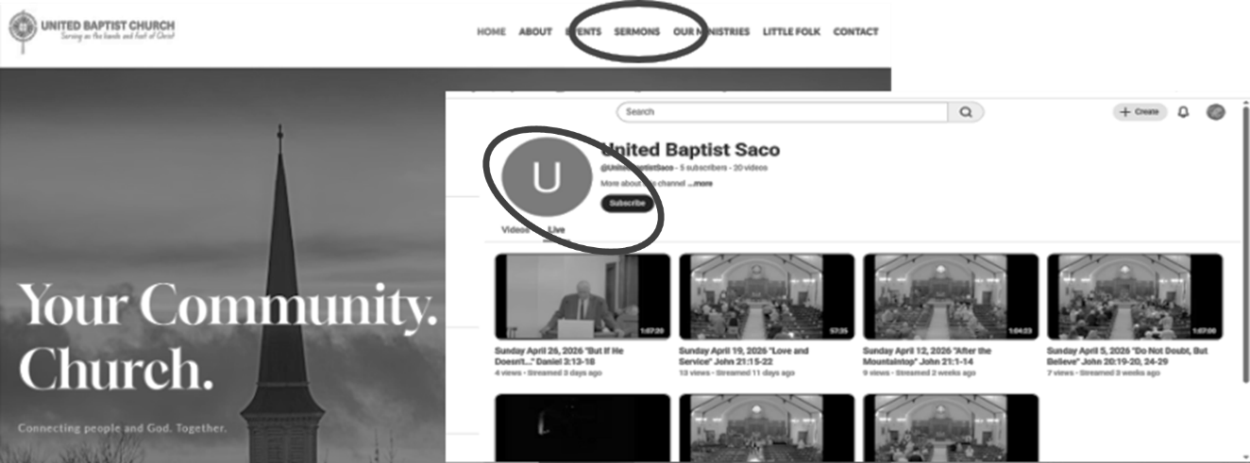

SECRET PLACE DEVOTIONALS
Large print Secret Place devotionals for summertime are available on the tables in the sanctuary. A $2 donation is requested.

CALLING ALL CRAFTERS!
Ideas for Holly Berry Fair craft projects are set up in the Youth Room (second floor). Take what you like and leave your name and phone number, so we’ll know what project you’re working on. Have questions? See Anne Daisey, chair,
207-229-9306 /daiseym266@gmail.com or Peggy Grant, Pam Salvas or Sue Bedell

OFFERING ENVELOPES
Do you have yours? If not, there are some in the back of the sanctuary. Choose an envelope number and sign your name to that number on the sheet. Using your envelopes is how we keep track of your giving. In January, you will be issued a statement for tax purposes.
OPPORTUNITIES AND INFORMATION
THE WEEK AHEAD:
TUESDAY 10:00 am -- Bible Study “The Story”
WEDNESDAY 5:00 pm – TOPS
THURSDAY 10:00 am – Food Commodity Distribution

PASTORAL CARE
Contact Pastor Dave directly: rev.drc1952@gmail.com, or 207-513-0114

MISSION UPDATE-MAY BUCKET CHALLENGE!
We are collecting Disposable Rain Ponchos and $5 Gas Cards. Seeds of Hope distributes the Gas Cards to their volunteer drivers who transport residents, and the un-housed are grateful for the ponchos. Coming up in June... Be sure to watch your bulletin insert for the June challenge! Thank you for helping those less fortunate.

SUMMERTIME READING
Our Library, located off the Vestry, has a wonderful selection of books for you to take and enjoy. There are books of fiction, non-fiction, history, pets and animals, many topics to delight both young and old. Check it out! Ruth Gladu is our librarian, and she is happy to help you.

PRAYER JAR
There is a prayer jar in the front of the sanctuary by the pulpit. We place marbles in the jar in recognition of, and celebration of answered prayers! Have you spoken to God, and has he shown you an answer? Placing a marble in the jar is a way to show God truly loves us and is at work in our lives!

CLYNK BAGS
We have CLYNK bags for you to take home and use for your returnable bottles and cans. The bags have the church barcoded stickers on them. Just fill the bag with empty cans and bottles (do not exceed 20 lbs.) and take them to any CLYNK depository in any Hannaford parking lot, scan the barcode to unlock the door and push the bag inside. CLYNK will do the calculations and credit the church’s account. The money goes into our Fellowship Fund-helping our church members.

OPPORTUNITIES AND INFORMATION

LIVE STREAM OUR WORSHIP SERVICE
If you are unable to attend a worship service, or would like to see the service again, you can watch the service at home. Go to our website: UnitedBaptistSaco.org , at the top, click on “sermons”. Then under the blue circle with the letter “U” in it, click
“Live”. Next, click on the photo with the date you want to watch.

SECRET PLACE DEVOTIONALS
Large print Secret Place devotionals for summertime are available on the tables in the sanctuary. A $2 donation is requested.

CALLING ALL CRAFTERS!
Ideas for Holly Berry Fair craft projects are set up in the Youth Room (second floor). Take what you like and leave your name and phone number, so we’ll know what project you’re working on. Have questions? See Anne Daisey, chair,
207-229-9306 /daiseym266@gmail.com or Peggy Grant, Pam Salvas or Sue Bedell

OFFERING ENVELOPES
Do you have yours? If not, there are some in the back of the sanctuary. Choose an envelope number and sign your name to that number on the sheet. Using your envelopes is how we keep track of your giving. In January, you will be issued a statement for tax purposes.

