CELEBRATION OF WORSHIP
July 12, 2026 - 9:00 a.m.
“God does not give us everything we want, but He does fulfill His promises, leading us along the best and straightest paths to Himself.” Dietrich Bonhoeffer
Announcements
Centering Prayer
“Call to me, and I will answer you and will tell you great and hidden things that you have not known.” Jeremiah 33:3

Organ Prelude: “Hiding in Thee” Page/Sankey Janice St. Cyr, organist
Call to Worship: Psalm 95
Leader: O come, let us sing to the Lord;
let us make a joyful noise to the rock of our salvation!
People: Let us come into His presence with thanksgiving;
let us make a joyful noise to Him with songs of praise!
Leader: O come, let us worship and bow down;
let us kneel before the Lord, our Maker!
People: For He is our God,
and we are the people of His pasture
and the sheep of His hand.
Invocation
*Gathering Hymn: #88 “Fairest Lord Jesus”
Gathering of Our Offerings
Offering envelopes are available in the pews.
Jesus said, “Freely you have received, freely give.” (Matthew 10:8)
*Hymn: #65 “The Wonder of It All”
*Prayer of Dedication
Offertory:
Pastoral Prayer and The Lord’s Prayer
Prayer Response: #394 “In My Life Lord, Be Glorified” (seated)

Scripture: Jonah 4:1-11 Read by Bob Corliss
But this was very displeasing to Jonah, and he became angry. ² He prayed to the Lord and said, “O Lord! Is not this what I said while I was still in my own country? That is why I fled to Tarshish at the beginning, for I knew that you are a gracious and merciful God, slow to anger, abounding in steadfast love, and relenting from punishment. ³ And now, O Lord, please take my life from me, for it is better for me to die than to live.” ⁴ And the Lord said, “Is it right for you to be angry?” ⁵ Then Jonah went out of the city and sat down east of the city and made a booth for himself there. He sat under it in the shade, waiting to see what would become of the city.
⁶ The Lord God appointed a bush and made it come up over Jonah, to give shade over his head, to save him from his discomfort, so Jonah was very happy about the bush. ⁷ But when dawn came up the next day, God appointed a worm that attacked the bush, so that it withered. ⁸ When the sun rose, God prepared a sultry east wind, and the sun beat down on the head of Jonah so that he was faint and asked that he might die. He said, “It is better for me to die than to live.”
⁹ But God said to Jonah, “Is it right for you to be angry about the bush?” And he said, “Yes, angry enough to die.” ¹⁰ Then the Lord said, “You are concerned about the bush, for which you did not labor and which you did not grow; it came into being in a night and perished in a night. ¹¹ And should I not be concerned about Nineveh, that great city, in which there are more than a hundred and twenty thousand persons who do not know their right hand from their left and also many animals?”
Message: “Those People” Pastor Dave
*Closing Hymn: #285 “In Christ There Is No East or West”
*Benediction
Postlude: “Lift Every Voice and Sing” R. Belfield

* Denotes please stand, as you are able
Please join us downstairs in the Vestry for a time of fellowship
WELCOME! We of United Baptist Church represent various religious and cultural backgrounds and lifestyles. We are young, old, and middle aged, single, married, widowed, divorced, parents, grandparents, and members of extended families. Above all, we are people who take risks, make mistakes, confess, repent and try again. At the center of our community is Jesus Christ whose life, death, and resurrection are the reasons we are together. The life and hope in this community have more to do with Christ’s faithfulness to us than ours to Christ. Whether you are searching for a faith community, or just passing through, we want you to feel at home. Whoever you are, whatever your history, your scars, your gifts, you are among people like yourself.
FLOWERS: are compliments of the Erwin Warren Flower Fund
GREETERS: David & Irene Hodges Amy Robinson
FELLOWSHIP HOUR: the board of Deacons
SPECIAL CARE CORNER
Jimmy Pate and family upon the passing of Clara 6/22
Linda Duranceau on the passing of Gary 6/27
Howard & Marianne Krueger  Burt Howe  Linda Fondak  Betty Hill | Cindy Neal  Cheryl Morse  Mary Jones  Bill Tarbox

UNITED BAPTIST CHURCH STAFF
INTERIM PASTOR: Rev. Dr. David Clark SECRETARY: Margie McDonald
BOOKKEEPER: Danielle Roberge MUSIC COORDINATOR: Glenn Moseley
ORGANIST: Janice St. Cyr
CHURCH OFFICE HOURS: TUESDAY – FRIDAY 8:00am – Noon
Church Office: (207) 283-3411 Pastor Dave: (207) 513-0114
Emails: ubcsaco.office@gmail.com rev.drc1952@gmail.com
Web site: unitedbaptistsaco.org - Friend us on Facebook: SacoUnitedBaptistChurch
The Past Has a Future at United Baptist!

THE UNITED BAPTIST CHURCH
318 Main Street. Saco, Maine 04072

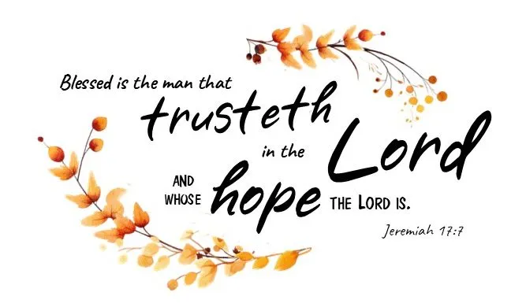

The Church in the Heart of Saco

OPPORTUNITIES AND INFORMATION

THE WEEK AHEAD:
WEDNESDAY 5:00 pm – TOPS
THURSDAY 6:30 pm – Condert rehearsal at St. Joseph’s

PASTORAL CARE
Contact Pastor Dave directly: rev.drc1952@gmail.com or 207-513-0114
Remember, due to HIPA laws, neither the church nor the pastor is notified if one of our members is hospitalized. Please have a friend or family member contact the pastor or the church office.

OFFICE TELEPHONE
Line one on the church office phone is not working correctly. If you need to call the office, please use line two – 282-0320. The phone company – Fidium- will come on Wednesday the 15th to repair it.

Thank you to ALL of you who sent me a card or prayed for me. I am finally recovering without a 10 on the pain scale and am hobbling around, but I will get there. Sending my Love to You.
Cheryl Morse

AND

Thank you from Burt and Pat Howe for all the cards, prayers and well wishes; they certainly lifted their spirits when they were down.

Howard and Marianne Krueger request a visit from you! Just drop in for a quick hello. They feel isolated and forgotten, and we, being their brothers and sisters in Christ, have not forget them!

SEARCH COMMITTEE UPDATE: All our preliminary work is completed, and we await news of possible candidates. Meanwhile, we will be doing a mock interview with a local pastor to sharpen our interviewing skills.
Cathy Larkin, Search Committee Chair

OPPORTUNITIES AND INFORMATION

ONE GREAT HOUR OF SHARING
Throughout the month of June, we accepted the One Great Hour of Sharing offering. You have given $1052 - Thank you very much!

BUCKET CHALLENGE For the summer months,
We are requesting donations of brand new and unopened hairbrushes, combs, shampoo, and conditioner (sample size OK).
Your continued giving fills a very important need in our community and is a blessing to those less fortunate. THANK YOU again for your generosity!

THE PARISH VISITOR
-takes a break in July and August. The September Parish Visitor will be chock-a-block full of church happenings! So, please remember, the deadline for items to be published in September is Monday, August 10th!

THE HOLLY BERRY FAIR is the first Saturday in December! NOW is the time for our volunteers and crafters to come in and pick up a project or two to work on during these summer months. Want more info? Call Anne Daisey 207-229-9306
or Sue Bedell 207-283-3757

OCEANS OF MERCY

Creator of the sea, thank you for the vast waters that stretch beyond my sight and the waves that rise and fall in faithful rhythm.

In the ocean’s depth, remind me to trust you. In its steady tides, teach me peace. When storms surround me, be my anchor and calm.

Wash my heart as the tide washes the shore, and let your love – deeper than the sea - carry me each day.

Amen

