CELEBRATION OF WORSHIP
September 13, 2026 - 10:00 a.m.
“The Bible isn’t about people trying to discover God, but about God reaching out to find us.” John Stott
Welcome and Announcements
Centering Prayer
Let the words of my mouth and the meditation of my heart be acceptable to you, O Lord, my rock and my redeemer. Psalm 19:14

Organ Prelude: “Spirit Song” J. Wimber Janice St. Cyr, organist
Call to Worship: from Isaiah 12
Leader: Surely God is my salvation; I will trust and will not be afraid,
People: for the Lord is my strength and my might; He has become my salvation.
Leader: “Give thanks to the Lord; call on His name; make known His deeds among the nations; proclaim that His name is exalted.
People: Sing praises to the Lord, for He has done gloriously;
let this be known in all the earth.
Invocation
*Gathering Hymn: #21 “Stand Up and Bless the Lord”
Gathering of Our Offerings
Offering envelopes are available in the pews.
Jesus said, “Freely you have received, freely give.” (Matthew 10:8)
*Hymn: #445 “Something for Thee”
Prayer of Dedication
Offertory: “He is So Precious to Me” C. Gabriel Susan Robinson, soloist
Pastoral Prayer and The Lord’s Prayer
Prayer Response: #465 “In His Time” (seated)

Scripture: 1 Corinthians 15:50-57 Read by Margie McDonald
⁵⁰ What I am saying, brothers and sisters, is this: flesh and blood cannot inherit the kingdom of God, nor does the perishable inherit the imperishable. ⁵¹ Look, I will tell you a mystery! We will not all die, but we will all be changed, ⁵² in a moment, in the twinkling of an eye, at the last trumpet. For the trumpet will sound, and the dead will be raised imperishable, and we will be changed. ⁵³ For this perishable body must put on imperishability, and this mortal body must put on immortality. ⁵⁴ When this perishable body puts on imperishability and this mortal body puts on immortality, then the saying that is written will be fulfilled:
“Death has been swallowed up in victory.”
⁵⁵ “Where, O death, is your victory?
Where, O death, is your sting?”
⁵⁶ The sting of death is sin, and the power of sin is the law. ⁵⁷ But thanks be to God, who gives us the victory through our Lord Jesus Christ.
Message: “The Dreaded Valley” Pastor Dave
*Closing Hymn: #220 “He Lives”
*Benediction
Postlude: “The Battle Belongs to the Lord” J. Owens-Collins

* Denotes please stand, as you are able

Please join us downstairs in the vestry for our annual Picnic!

WELCOME! We of United Baptist Church represent various religious and cultural backgrounds and lifestyles. We are young, old, and middle aged, single, married, widowed, divorced, parents, grandparents, and members of extended families. Above all, we are people who take risks, make mistakes, confess, repent and try again. At the center of our community is Jesus Christ whose life, death, and resurrection are the reasons we are together. The life and hope in this community have more to do with Christ’s faithfulness to us than ours to Christ. Whether you are searching for a faith community, or just passing through, we want you to feel at home. Whoever you are, whatever your history, your scars, your gifts, you are among people like yourself.
FLOWERS: are courtesy of the Erwin Warren Flower Fund
GREETERS: Margie McDonald Ann Lane-Nelson
FELLOWSHIP HOUR: All Church Picnic!
SPECIAL CARE CORNER
Tony Fondak and family as they mourn | Linda’s passing 9/1
Howard & Marianne Krueger  Burt Howe  Peggy Ricker | Cheryl Morse  Bill Tarbox  Betty Hill

UNITED BAPTIST CHURCH STAFF
INTERIM PASTOR: Rev. Dr. David Clark SECRETARY: Margie McDonald
BOOKKEEPER: Danielle Roberge MUSIC COORDINATOR: Glenn Moseley
ORGANIST: Janice St. Cyr
CHURCH OFFICE HOURS: TUESDAY – FRIDAY 8:00am – Noon
Church Office: (207) 283-3411 Pastor Dave: (207) 513-0114
Emails: ubcsaco.office@gmail.com rev.drc1952@gmail.com
Web site: unitedbaptistsaco.org - Friend us on Facebook: SacoUnitedBaptistChurch
The Past Has a Future at United Baptist!

THE UNITED BAPTIST CHURCH
318 Main Street. Saco, Maine 04072

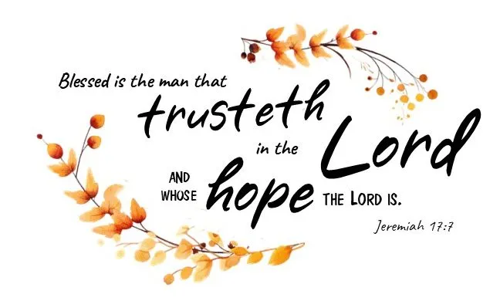

The Church in the Heart of Saco

OPPORTUNITIES AND INFORMATION

THE WEEK AHEAD:
WEDNESDAY 5:00 pm – TOPS

PASTORAL CARE
Contact Pastor Dave directly: rev.drc1952@gmail.com or 207-513-0114.
Remember, due to HIPAA laws, neither the church nor the pastor is notified if one of our members is hospitalized. Please have a friend or family member contact the pastor or the church office.

TUESDAYS TOGETHER
Since Bible Study will not start again until February 2027, the group would like to continue meeting in the Parlor for fellowship on Tuesdays from 10 to 11 am. We can pray, share bible verses, books we like, and have devotions. Start date: Oct 6.

COMING SOON:
World Mission Offering “WMO”
We will dedicate time in Sep and Oct to learn about and give to the World Mission Offering.
God is at work through global servants and International Ministries partners as they educate, heal and restore lives in the communities they serve.
Giving generously to the WMO is the best way to make sure that you support all of IM’s ministries. Let us come together and celebrate what God is doing around the world to rebuild, restore and renew.

And… Our Global Servant Christy Engle will be presenting the message on November 1st! Come and be inspired!

PRAYER JAR
We have a prayer jar near the pulpit for you to drop a marble in to recognize answered prayers. This helps you to be aware of God at work in your life, and the jar stands as a testimony to others.

OPPORTUNITIES AND INFORMATION

WANTED!
We are looking for donations of jig saw puzzles! 250, 300 or 500 pieces preferred.

The BUCKET CHALLENGE continues through September!
Donations of brand new and unopened hairbrushes, combs, shampoo, and conditioner (sample size OK) are needed.
Your continued giving fills a very important need in our community and is a blessing to those less fortunate. THANK YOU again for your generosity!

THE HOLLY BERRY FAIR
-is coming quickly! We need at least six more volunteers –2 for selling the Christmas wreaths, and 2 to work at the center craft table, and a cashier and another helper or 2 on the food table. Speak with either Anne Daisey 207-229-9306 or Sue Bedell 207-283-3757, or Margie 207-590-9666. Questions and suggestions are welcome!

JAMES KENNERLEY
Portland’s Municipal Organist on the Kotzschmar Organ, will present a concert on September 18th at the Ogunquit Baptist Church, 157 Shore Rd Ogunquit, at 730 pm.

THE MARK THALLANDER FOUNDATION
Will be presenting 2 two musical programs:
First, The New England Festival of Organ Music, featuring Hector Olivera
Sunday, September 20th at 3 pm, at the Basilica of Saints Peter & Paul
122 Ash St, Lewiston, ME 04240 (207) 777-1200
And
The New England Fall Organ Festival, featuring Bradley Hunter Welch
Sunday, October 18, at 6pm.
First Parish Church, 218 Central Ave, Dover, NH 03820 - (603) 742-5664
Go to markthallanderfoundation.org for more information.

