The Pastor’s Page

October is my favorite month of the year, for many reasons. One of them is that it is a
significant month for my family. In October, we celebrate: my younger brother’s
birthday; my middle daughter’s birthday; my older brother’s and his wife’s anniversary;
my wife, Wandah’s, and my anniversary; and my birthday. We keep Hallmark in
business this month!

One of the greatest of my blessings is my family. My Mom and Dad were wonderful
parents, and they instilled in us the importance of family ties. The members of my
family lead very different lives, and are dispersed in different localities, but we remain
closely knit. Love and loyalty are practiced. We truly care for one another. No one gets
left out. We are there for one another whenever need arises. As I said, I am truly
blessed.

I am also blessed by being a part of a church family. Wherever God has called us to
serve, we’ve always been blessed by the family of God with whom we serve. United
Baptist is no exception. Though in one sense we are outsiders, and our tenure here will
be limited, we nevertheless have felt a kinship with you all. You have welcomed
Wandah and me and taken us into your hearts. You have inspired us by your spirit of
service. You’ve made us laugh. We’ve felt included. You’ve modeled the old Olive
Garden slogan – “when you’re here, you’re family.”

Having a church family makes such a difference. If you haven’t been here in a while,
why not rejoin us? You will be warmly welcomed, I assure you.
It pains me to think of what so many are missing who do not have a church family. If
you feel the same way, then think about who you know who could benefit from having a
church family, and invite them to yours’. They just might say “yes.”

Your brother,

Pastor Dave

Peaceful thankful heart

American Baptist Churches of Maine (ABCOM)
The Annual Meeting of ABCOM, of which our church is a part, will be held on October
23-24 at Warren Baptist Church in Warren. This year’s theme is, “Celebrating the
Church.” Among the speakers will be our own Pastor Dave, who will be giving a
keynote message on Friday the 23rd at the 2:00 pm session. Anyone may register and
attend any or all of the sessions. Information on registration and costs, lodging,
directions, schedule, etc. can be found at abcom.org.

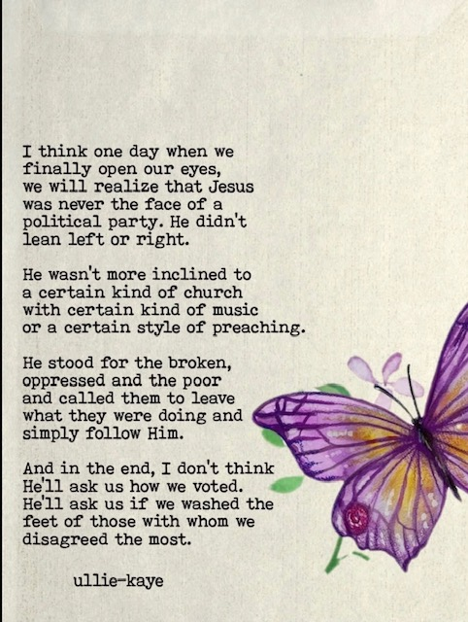

World Mission Offering
Every fall, the churches of our denomination promote the Word Mission Offering
(WMO). This offering supports the ministry of International Ministries (IM), the global mission agency of our denomination. Our financial support makes it possible for our Global Servants who serve in many and varied parts of the globe to expand the Kingdom of God through a variety of ways (e.g. evangelism and church planting, medical and educational ministries, relief and development projects, assisting indigenous churches, etc.) They also allow us to partner with Baptist unions in many countries to encourage and support their ministries among their own people. As a Board Member of IM, I (Pastor Dave) can assure you that the finances of IM are carefully, prayerfully, and faithfully managed and dispersed. I can also assure you that the work of our Global Servants and partner organizations is bearing fruit throughout the world. I highly urge you to consider giving generously to WMO through our church. Offering envelopes will be in the pew racks, can be dropped off during business hours, or mailed to the church.
One of our Global Servants, Kristy Engel will be with us on Sunday November 1st to share the morning message and tell us about her ministry.


WORKING WITH THE YOUNGER SET
Would you like to work with Linda Blades and Nancy deMiranda, and be available to facilitate a time during the worship hour, where children would go to do a lesson or have playtime? A lesson plan or activity would be available to you. If you’re ready to step up and be with any child or children who come to church, please email Andrea Dresser at celticmist50@gmail.com and we will set up a time to brainstorm together with Nancy and Linda. This is a very rewarding endeavor – close your eyes and open your heart and let God speak to you!


LIVE STREAM OUR WORSHIP SERVICE
If you are unable to attend a worship service at UBC, or would like to see the service again, you can watch the service live at home. Go to our website: unitedbaptistsaco.org , at the top, click on “sermons”. Then under the blue circle with the letter “U” in it, click “Live”. Next, click on the photo with the date you want to watch.

THE BUCKET CHALLENGE

The Board of Mission
For the October Bucket Challenge, our Board of Mission will be collecting Men’s & Women’s socks. So easy and so needed!!!
Thank you!


UPDATE FROM THE SEARCH COMMITTEE
The Search Committee continues to work diligently on finding our next pastor. Thank you all for your prayers. As a committee, we have a real sense that you are praying for us and our church as we set about doing this work.
The update is this: we are closer than we were two months ago! No promises that a quick resolution is near but we have made good progress in the last two months. Keep praying!
Cathy Larkin, Search Committee Chair.

HOLLY BERRY FAIR – DECEMBER 5, 2026 – 8:30 – 1:00 PM
It’s coming quickly!

We have had a donation of yarn in various colors and weights for you to take to make knit items for the fair! The yarn is in the “craft room” on the second floor past Pastor’s office on the right. Help yourself!
And-we need at least 5 more volunteers –2 for selling the Christmas wreaths, and 2 to work the center craft table, and 1 on the food table. Speak with either Anne Daisey 207-229-9306 or Sue Bedell 207-283-3757, or Margie 207-590-9666. Questions and suggestions are welcome!
Did you enjoy working on projects during the summer?
Ann Daisey- Chairman
Peggy Grant Pam Salvas
Sue Bedell



TUESDAYS TOGETHER
Since Bible Study will not start again until February 2027, the group would like to continue meeting in the Parlor for fellowship on Tuesdays from 10 to 11 am. We can pray, share bible verses, books we like, and have devotions. Start date: Oct 6.

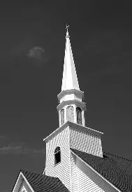
WHAT’S GOING ON AROUND HERE?? Take a walk out front and look up! Our Main St. doors got their final coat of paint. Thank you to the trustees for taking good care of this “Grand Old Lady”! Work continues on the steeple. We are currently waiting for the new composite shingles to arrive…they are in stock, but they will take 4- 6 weeks to get here. That’s right. The shingles are coming from Canada.


THE MARK THALLANDER FOUNDATION
Will be presenting The New England Fall Organ Festival, featuring Bradley Hunter Welch, Sunday, October 18, at 6pm.
First Parish Church, 218 Central Ave, Dover, NH 03820
(603) 742-5664. Go to markthallanderfoundation.org for more information.

FUNNY STUFF…
What do you get when you cross a snowman and a vampire? Frostbite.
Why do Christmas trees like the past? Because the present’s beneath them.
How do angels greet each other? “Halo!”
What kind of lights did Noah have on the ark? Flood lights.
What did Daniel tell his real estate agent? “I prefer a house with no den.”
How do you make holy water? You boil the devil out of it.
Why did the scarecrow become a Sunday School teacher? Because he was outstanding in his field.
How do we know Peter was a rich fisherman? By his net income.
What’s a missionary’s favorite kind of car? A convertible.
What do you call a sleepwalking nun? A roamin’ Catholic.
Why didn’t they play cards on the Ark? Because Noah was always standing on the
deck.
What’s a missionary’s favorite kind of car? A convertible.
How does Moses make his coffee? Hebrews it!


AN UPDATE ON OUR BACKPACK PROJECT!
A BIG THANK YOU goes out to all who donated backpacks and school supplies. We were given a cash gift of $500, and Andrea Dresser went to the Trustees and the Board of Christian Ed, and asked both those groups to match that $500, and both agreed! Fifteen hundred dollars has gone to the “Aid for Saco Kids” fund! Now, children less fortunate will get what they need in order to have a good school year! Thank you to Sue Bedell, Allison Desjardins and Amy Tousignant at the Saco schools, and thank you to Andrea Dresser, our Trustees and the Board of Christian Ed!

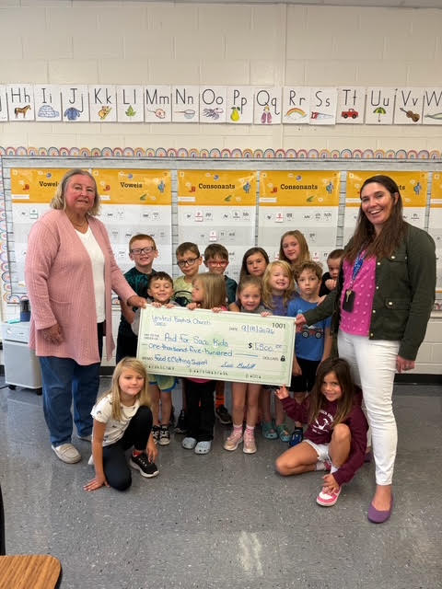


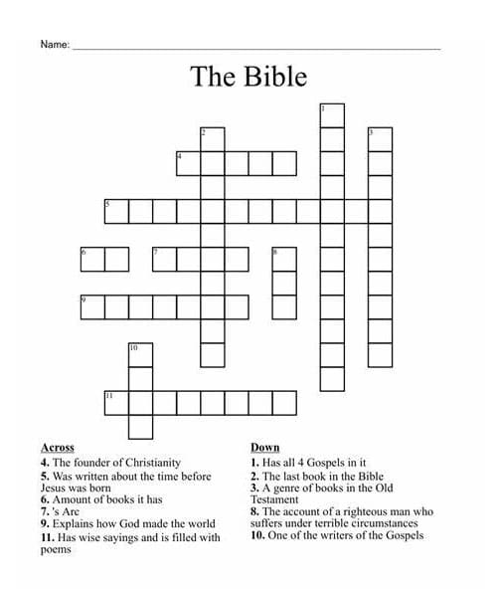
United Baptist Church
318 Main St.
Saco, ME 04072

October 2026
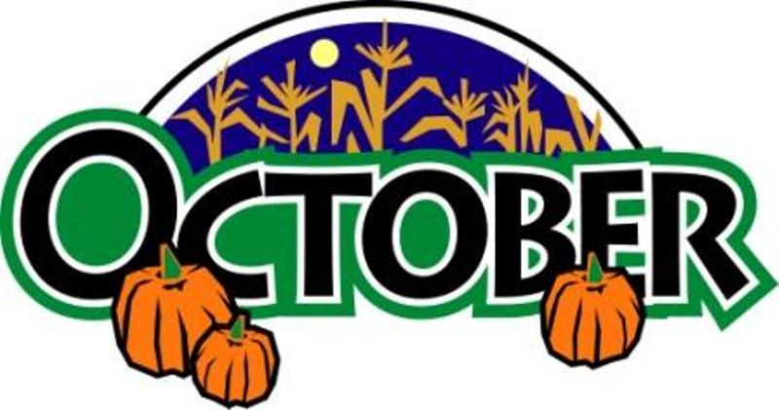

UNITED BAPTIST CHURCH STAFF
INTERIM PASTOR: Rev. Dr. David Clark SECRETARY: Margie McDonald
BOOKKEEPER: Danielle Roberge MUSIC COORDINATOR: Glenn Moseley
ORGANIST: Janice St. Cyr
CHURCH OFFICE HOURS - TUESDAY – FRIDAY 8:00am – Noon
Church Office: (207)283-3411 Pastor Dave (207)513-0114
Emails: rev.drc1952@gmail.com ubcsaco.office@gmail.com
Web site: unitedbaptistsaco.org - friend us on Facebook: sacounitedbaptistchurch

