CELEBRATION OF WORSHIP
June 28, 2026 - 9:00 a.m.
"If you believe what you like in the Gospel, and reject what you don't like, it is not the Gospel you believe, but yourself." St. Augustine
Announcements
In Memoriam: Clara Pate
Centering Prayer
“Lord, speak, for Your servant is listening.” 1 Samuel 3:10

Organ Prelude: “Air from Overture in D” JS Bach Janice St. Cyr, organist
Call to Worship: Psalm 89
Leader: I will sing of Your steadfast love, O Lord, forever; with my mouth I will proclaim Your faithfulness to all generations.
People: I declare that Your steadfast love is established forever;
Your faithfulness is as firm as the heavens.
Leader: Let the heavens praise Your wonders, O Lord, Your faithfulness in the assembly of the holy ones.
People: Blessed be the Lord forever. Amen and Amen.
Invocation
*Gathering Hymn: #97 “All Hail the Power of Jesus’ Name”
Gathering of Our Offerings
Offering envelopes are available in the pews.
Jesus said, “Freely you have received, freely give.” (Matthew 10:8)
*Hymn: #445 “Something for Thee”
*Prayer of Dedication
Offertory: “No Higher Calling” Leblanc and Gulley the Choir
Pastoral Prayer and The Lord’s Prayer
Prayer Response: #383 “Open Our Eyes, Lord” (seated)

Scripture: Jonah 4:1-11 Read by Bill Soucy
But this was very displeasing to Jonah, and he became angry. 2 He prayed to the Lord and said, “O Lord! Is not this what I said while I was still in my own country? That is why I fled to Tarshish at the beginning, for I knew that you are a gracious and merciful God, slow to anger, abounding in steadfast love, and relenting from punishment. ³ And now, O Lord, please take my life from me, for it is better for me to die than to live.” ⁴ And the Lord said, “Is it right for you to be angry?” ⁵ Then Jonah went out of the city and sat down east of the city and made a booth for himself there. He sat under it in the shade, waiting to see what would become of the city.
⁶ The Lord God appointed a bush and made it come up over Jonah, to give shade over his head, to save him from his discomfort, so Jonah was very happy about the bush. ⁷ But when dawn came up the next day, God appointed a worm that attacked the bush, so that it withered. ⁸ When the sun rose, God prepared a sultry east wind, and the sun beat down on the head of Jonah so that he was faint and asked that he might die. He said, “It is better for me to die than to live.”
⁹ But God said to Jonah, “Is it right for you to be angry about the bush?” And he said, “Yes, angry enough to die.” ¹⁰ Then the Lord said, “You are concerned about the bush, for which you did not labor and which you did not grow; it came into being in a night and perished in a night. ¹¹ And should I not be concerned about Nineveh, that great city, in which there are more than a hundred and twenty thousand persons who do not know their right hand from their left and also many animals?”
Message: “Is It Right for You to Be Angry?” Pastor Dave
*Closing Hymn: #460 “All the Way My Savior Leads Me”
*Benediction
Postlude: “Canticle of the Turning” R. Clooney
* Denotes please stand, as you are able
Please join us downstairs in the Vestry for a time of fellowship
WELCOME! We of United Baptist Church represent various religious and cultural backgrounds and lifestyles. We are young, old, and middle aged, single, married, widowed, divorced, parents, grandparents, and members of extended families. Above all, we are people who take risks, make mistakes, confess, repent and try again. At the center of our community is Jesus Christ whose life, death, and resurrection are the reasons we are together. The life and hope in this community have more to do with Christ’s faithfulness to us than ours to Christ. Whether you are searching for a faith community, or just passing through, we want you to feel at home. Whoever you are, whatever your history, your scars, your gifts, you are among people like yourself.
FLOWERS: are compliments of the Erwin Warren Flower Fund
GREETERS: Ann Grant Bill Soucy
FELLOWSHIP HOUR: Ava Adams and Robert Talley
SPECIAL CARE CORNER
Jimmy Pate and family upon the passing of Clara 6/22
Gary Duranceau  David Hodges  Howard & Marianne Krueger  Burt Howe  Linda Fondak | Cindy Neal  Cheryl Morse  Mary Jones  Bill Tarbox

UNITED BAPTIST CHURCH STAFF
INTERIM PASTOR: Rev. Dr. David Clark SECRETARY: Margie McDonald
BOOKKEEPER: Danielle Roberge MUSIC COORDINATOR: Glenn Moseley
ORGANIST: Janice St. Cyr
CHURCH OFFICE HOURS: TUESDAY – FRIDAY 8:00am – Noon
Church Office: (207) 283-3411 Pastor Dave: (207) 513-0114
Emails: ubcsaco.office@gmail.com rev.drc1952@gmail.com
Web site: unitedbaptistsaco.org - Friend us on Facebook: SacoUnitedBaptistChurch
The Past Has a Future at United Baptist!

THE UNITED BAPTIST CHURCH
318 Main Street. Saco, Maine 04072

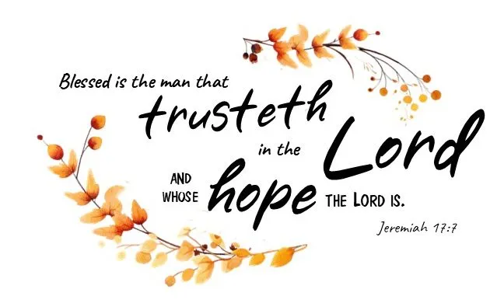

The Church in the Heart of Saco

OPPORTUNITIES AND INFORMATION

THE WEEK AHEAD:
WEDNESDAY 5:00 pm – TOPS
THURSDAY 10:00 am – Food Commodity Distribution
FRIDAY CHURCH OFFICE CLOSED FOR THE HOLIDAY

ONE GREAT HOUR OF SHARING
We will be accepting the One Great Hour of Sharing offering throughout the month of June. Envelopes can be found in your pew racks. So far this month, we have collected $816 - Thank you.

BUCKET CHALLENGE For the summer months,
We are requesting donations of brand new and unopened hairbrushes, combs, shampoo, and conditioner (sample size OK).
Your continued giving fills a very important need in our community and is a blessing to those less fortunate. THANK YOU again for your generosity!

PASTORAL CARE
Contact Pastor Dave directly: rev.drc1952@gmail.com or 207-513-0114
Remember, due to HIPA laws, neither the church nor the pastor is notified if one of our members is hospitalized. Please have a friend or family member contact the pastor or the church office.

THE PARISH VISITOR
-takes a break in July and August. The September Parish Visitor will be chock-a-block full of church happenings! So, please remember, the deadline for items to be published in September is Monday, August 10th!

PERSONAL HEARING SPEAKERS
We have headsets in the narthex, that are speakers tied directly into the sound system. There is no need to struggle to hear the service. Ask Bill Soucy or Margie McDonald for help.
OPPORTUNITIES AND INFORMATION

PERFUMES AND COLOGNES
Please be aware, some in our congregation are sensitive to, and/or have allergies to fragrances. Please limit your use of these when attending church gatherings.

CHURCH ORNAMENT
As you know, 2024 was the 100th anniversary of the merging of Main Street and Cutts Avenue churches. We have a commemorative Christmas tree ornament to celebrate that event, available for purchase in the vestry for $5. (a great stocking stuffer!)

PRAYER JAR
We have a prayer jar near the pulpit for you to drop a marble in to recognize answered prayers. This helps you to be aware of God at work in your life, and the jar stands as a testimony to others.

LIVE STREAM OUR WORSHIP SERVICE
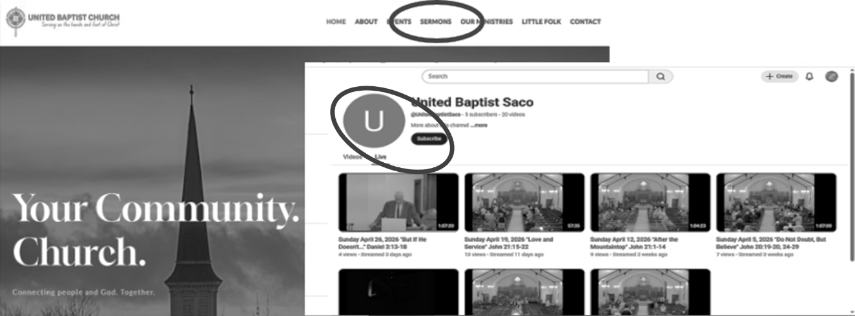
Go to our website: unitedbaptistsaco.org , at the top, click on “sermons”. Then under the blue circle with the letter “U” in it, click “Live”. Next, click on the photo with the date you want to watch.

"The hours when the mind is absorbed by beauty are the only hours when we really live.”
Richard Jeffries

