Annual Report from the Pastor for the Year 2025
This will be my final annual report as pastor of United Baptist Church before I head into retirement on December 31, 2025. David and I first came to United Baptist as parishioners with our two young children in January of 1984. Over the following years, I taught various ages of Sunday School, then became Director of Christian Education and served on every Board and Committee within the church. In the 1990’s I began attending Seminary and became the Pastoral Associate and was ordained here on December 21, 2003. When Rev. Dr. Burt Howe retired in 2014, I became the Acting Pastor and then the settled Pastor in November 0f 2015. Through these years, we have come to know and care about one another deeply. I will miss you all very much, but God has shown me that it is time for me to retire.

Going to Seminary is, I think, a lot like going to culinary school. You learn the basic foundations, some cool party tricks, and at the end you can prepare a gourmet meal. Pastoring, however, is waking up every day to a new episode of Chopped, where the ingredients are completely random and you are expected to do something with whatever you are handed while everyone watches and provides running commentary, and occasionally, something explodes! (By Tim Peter – High Church Coyote)

Seminary did not prepare me for much of what my years as Pastor brought. Who would have thought that during my tenure here the church’s heating system would give out in January, 2020 leaving us with no heating system in the middle of winter. We got a new heating system in March – right before a world-wide pandemic shut everything down. We had never experienced such things before, but together, we figured out how to be the church, and it drew us closer together. We came out of Covid a different church in many ways, and we found our church to be much smaller as the inevitability of drifting away, death, and relocation have taken many beloved friends from our midst.

Yet, we have remained a faithful community of Christ’s people and will continue to be so. In the months to come, the church will be well served by Interim Pastor the Rev. Dr. David Clark, someone I know and deeply respect. I ask that you support Rev. Clark and his wife Wandah and their ministry among you wholeheartedly and with joy! The Search Committee will continue their good work to find the next Settled Pastor that God is preparing for this church. Under the guidance of a very capable interim pastor and the prayerful seeking of God’s guiding Spirit in the process, I am confident the right spiritual leader will emerge through the search process. Finding the right Pastor for United Baptist is important, and the search process may take some time. Be patient. Trust in God. Be strong and courageous.

This is not the time to step back from the life of this, your church. It is vitally important that you continue to support the church through your attendance in worship, through your ongoing contact with one another, through your participation in events that happen at church during the week, and through your financial support. Our church is smaller than it was, and that means that each individual – you - are even more important in the continued good health of this congregation. Support each other and prayerfully be open to how God may be leading each one of you to actively take part in the life of this church in order to keep things moving in a good, hope-filled path. The church has before it a wonderful new opportunity to see God at work and to embark on a Spirit led journey.

It has been a privilege and pleasure to be a part of the history of this church and the personal lives of so many of you. There are very few people who know the complexities of pastoral ministry and the many things contained in the mixture of working with people and families from the beginning of lives to the end of lives and all that lies in between. I thank you for allowing me in to that kind of spiritual intimacy. I know God has blessed us in this journey together, and that God will continue to bless us in our future lives.

Blessings –
Reverend Beverly M. Lowell, December, 2025

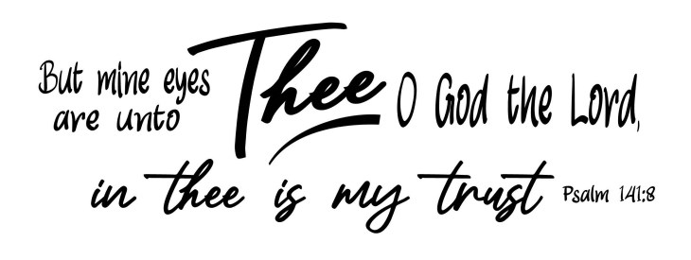

OUR INTERIM MINISTER BEGINS SUNDAY, JANUARY 4, 2026
The Reverend Doctor David Clark will be with us beginning January 4, 2026! Reverend Clark, (Pastor Dave) grew up in Holliston, MA where he accepted the Lord at age 16. He received a Bachelor’s Degree from Gordon College in 1974, a Master of Divinity from Trinity Evangelical Divinity School in 1978 and a Doctor of Ministry from Gordon Conwell Theological Seminary in 2003. He was ordained in 1978 and has Pastored churches in Canada, and in Maine at Hollis, Nobleboro, Ogunquit and Auburn American Baptist churches. He has held Interim Pastorates in Bowdoinham and Otisfield. He currently serves on the Board of Directors for ABCUSA International Ministries.
While Pastor Dave has many years of experience, he will take him a bit to become familiar with how UBC does things! Reverend Clark plans on being here on Wednesdays and Sundays. More on that to come! We look forward to his ministry with us!


NEW EMAIL FOR PASTOR
As of December 30th, Beverly’s email account ubc.bev@gmail.com will no longer exist. Please make note of this change. The new email in order to communicate with Pastor Dave will be rev.drc1952@gmail.com The email for the church office, ubcsaco.office@gmail.com will not change.

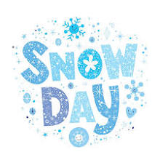
SNOWY SUNDAYS
It is very possible that we will have a Sunday this winter when the weather is not good. Our Interim Pastor, Pastor Dave, lives in Auburn and there may be some Sundays when the weather makes travel here to Saco unsafe.
In that event, our Sunday worship service might be called off. How will you know? Tune to WCSH 6 or WGME 13 and watch for the storm closing announcements. If worship is canceled here at UBC, the announcement of cancellation should be there. You can always go to our church web site ubcsaco.org, and watch a past service on YouTube!
As always, even if there is worship, you need to use good judgment as
to whether or not it is safe for you to travel!

ANNUAL CHURCH MEETING – NOTICE TO ALL MEMBERS OF UBC
The Annual Church business meeting of the United Baptist Church of Saco, Maine will be held on Sunday, January 18, 2026, following our worship service. It will begin with a luncheon in our Vestry, and then move into the meeting. The purpose of this meeting is to attend to all business affairs of the church, financial and otherwise, as presented.
Storm date will be January 25, 2026, at 11:15. Ann Grant, Clerk

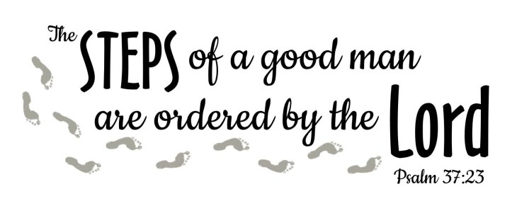

JANUARY CHURCH BOARD MEETINGS – JANUARY 21, 2026 – 6:30pm
First, we want to thank all the Board and Committee members who finished their term in 2025. The work you did to carry out the mission of United Baptist is much appreciated!
Our Nominating Committee will be presenting a full slate of new Board members to be voted on at our Annual Meeting to be held Sunday, January 18 in the Vestry following worship.
Normally our Boards meet on the second Wednesday of the month, but because the Annual
Meeting will be on the third Sunday, the January meetings of our Boards and Committees will be on the third Wednesday, January 21, 2026.
We are grateful for everyone who has agreed to serve in these upcoming years, and thank you for your service! We are a stronger church because of you.

TUESDAY BIBLE STUDY

Our Tuesday morning Bible study is taking a winter break and will resume at the end of February as we prepare to enter the Season of Lent. Andrea Dresser will continue the Bible study we began in September, engaging Max Luccado and Randy Frazee’s book The Story. The Story features the story of the Bible – in its own words – is chronologically arranged and tells of the events, people and teachings of the Bible. It is the story of our God who loves his children and reveals a God of Grace. The study uses a video
and discussion and is open to all. Watch for more details to come.


BAPTISMS
On December 14th we welcomed through the waters of Baptism Blessing Bambi, Joyce Bambi, Angel Bambi and Nicole Morse. What a joy it was to have them make their public profession of faith! At the close of the service, we had our Salt and Light Ceremony and welcomed them all into membership at United Baptist.


RETIRED MINISTERS AND MISSIONARY OFFERING
Throughout the month of December, we accepted the Retired Ministers and Missionary offering. As of the date of the Visitor publication, we have collected $440.00. Thank you to all who gave!

HOLLY BERRY FAIR
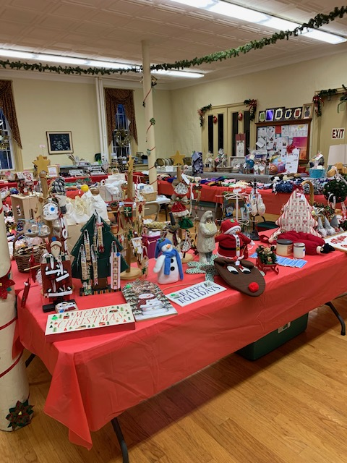
A big Thank You to everyone who worked or came to the fair on December 6th. What a wonderful day! Everyone seemed to enjoy the fellowship and walking around the fair seeing one another, and we had a lot of crafts, baked goods, Grandma’s Christmas Attic, jewelry, baskets and puzzles for everyone to enjoy. We netted $4042.11! (Still not sure where the eleven cents came from!!) The Fair Committee, Sue Bedell, Pam Salvas, and Rita Smith, and Donna Snow, have decided to divide the proceeds between our Fellowship Fund, T.A. Student Aid, Seeds of Hope, Saco Food Pantry, and the Saco Meals Program.
The Chairs of our 2026 Fair Committee will be Sue Bedell and Anne Daisey. Sue has years of experience with the ins and outs of the Fair, and Anne brings new ideas and energy; they are going to make a wonderful team!
The fair committee will be back to work in March to start the plans for the Holly Berry Fair, 2026. If anyone is interested in joining us in the planning, we would love to have you join in the fun, fellowship, and great satisfaction in producing a wonderful fair!

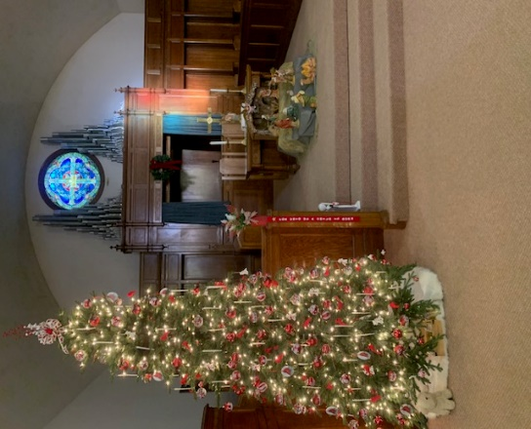
THANKS TO OUR FLOWER AND
DECORATING COMMITTEE!
Our Decorating and Flower Committee does a marvelous job through the year of decorating for the various seasons, with a special focus of course on Easter, Thanksgiving, and Christmas.

We are grateful for everyone’s good work, especially that of Peggy Grant who spends countless happy hours planning and placing the decorations.

We also thank our Flower Committee for the beautiful arrangement of the poinsettias that so enhanced the beauty of our Sanctuary on Christmas Sunday and Christmas Eve.

Giggle Page

Pastoral Perfection
Good news! After hundreds of years of ministers, a model pastor has been found – one who will please every church member.

He/She is twenty-six years old and has been preaching for thirty years. They are tall, short, thin, heavyset, handsome/beautiful, and has one brown eye and one blue eye. Their hair is parted in the middle (blonde), left side (dark and straight), and on the right side (brown and wavy).
They have a burning desire to work with teenagers and spend all their time with older folks. They smile all the time with a straight face because they have a sense of humor that keeps them seriously dedicated to their work.
They make fifteen calls a day on church members, spend all their time evangelizing the lost, and never leave their office.

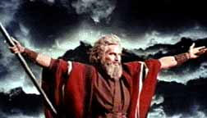
What I learned in Sunday School
The Egyptians were all drowned in the dessert.
Afterwards, Moses went up on Mount Cyanide to get the ten amendments.
Moses died before he ever reached Canada.
Solomon, one of David’s sons, had three hundred wives and seven hundred porcupines.
Jesus was born because Mary had an immaculate contraption.
Jesus enunciated the Golden Rule, which says to do one to others before they do one to you.
St. Paul cavorted to Christianity. He preached holy acrimony, which is another name for marriage.

Dear Pastor, Please pray for all the airline pilots. I am flying to California tomorrow.
Laurie. Age 10, New York City

Dear Pastor, Please say a prayer for our Little League team. We need God's help or a new pitcher. Thank you. Alexander. Age 10, Raleigh

Dear Pastor, I would like to go to heaven someday because I know my brother won't be there. Stephen. Age 8, Chicago
Dear Pastor, My father says I should learn the Ten Commandments. But I don't think I want to because we have enough rules already in my house. Joshua. Age 10, South Pasadena
Dear Pastor, I liked your sermon on Sunday. Especially when it was finished.
Ralph, Age 11, Akron

UNITED BAPTIST CHURCH
318 MAIN STREET
SACO, MAINE 04072

JANUARY, 2026


UNITED BAPTIST CHURCH STAFF
INTERIM PASTOR: Rev. Dr. David Clark ADMINISTRATIVE ASSISTANT: Margie McDonald
BOOKKEEPER: Danielle Roberge MUSIC COORDINATOR: Glenn Moseley
ORGANIST: Janice St. Cyr

CHURCH OFFICE HOURS - TUESDAY – FRIDAY 8:00am – Noon
Telephone (207)283-3411 (207)282-0320
Email: rev.drc1952@gmail.com ubcsaco.office@gmail.com
Web site: unitedbaptistsaco.org Friend us on Facebook: sacounitedbaptistchurch

